Progress report on the histological analysis of gonads for estimating the maturity schedule of swordfish Xiphias gladius caught
in the North Pacific

Hiroshi Ashida¹, Yuki Ishihara¹, Michael Kinney², Kristen Dahl², Yi-Jay Chang³,
Zi-Wei Yeh³, and Mikihiko Kai¹

¹Fisheries Resources Institute, Highly Migratory Resources Division,
Japan Fishery Research and Education Agency
2-12-4 Fukuura, Kanazawa, Yokohama, Kanagawa 236-8648, JAPAN
² Pacific Islands Fisheries Science Center
NOAA Fisheries, U.S. Department of Commerce,
³Institute of Oceanography,
National Taiwan University

Email: ashida_hiroshi35@fra.go.jp

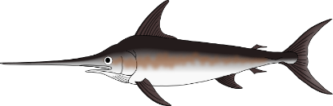

Abstract
This document reports the recent progress in sample treatment for estimating the maturity schedule of swordfish in the North Pacific. A total of 913 swordfish gonads were collected between 2020 and 2024 for histological analysis, and the maturity status of each gonad was assessed through histological observation. The sex ratio varied depending on eye-fork length (EFL) class and subarea, skewing toward females in larger size classes. Mature and spawning females were primarily distributed south of 30°N, whereas mature males were found throughout the entire sampling area. Mature and spawning females were mainly observed from January to August, while mature males were present year around. In the present study, the minimum size at maturity was 130 cm EFL for females and 74.5 cm EFL for males.
The results of present study suggest that the distribution of mature and spawning females is latitudinally biased. Therefore, to accurately estimate the maturity schedule and characterize the reproductive traits of swordfish, gonad sampling efforts should be intensified in areas south of 30°N in the North Pacific.

- Introduction
Swordfish (Xiphias gladius) are distributed across a broad range from temperate to tropical areas and are one of the main target species in the tuna longline fishery (Nakamura 1985). The annual catch of swordfish in the North Pacific ranged from 6,522 to 8,867 tons between 2020 and 2024 (ISC 2025).
Swordfish larvae in the North Pacific were distributed across a broad area between 0° and 30°N and 120°E and 150°W throughout the year (Nishikawa et al. 1985). Notably, the catch per tow of swordfish larvae peaked during the 2nd quarter (April-June, Nishikawa et al. 1985). Yabe et al. (1959) inferred that swordfish spawn from February to August throughout the wide area of the southern waters of the Subtropical Convergence Zone in the North Pacific Ocean based on information gained from the collection of ripe ovaries (i.e. ovary weight >3kg), larvae, and juveniles. In the Eastern Pacific Ocean, the specimens with a gonad index greater than 3, mainly occurred in the south of 10°N throughout year (Kume and Joseph 1969).
In addition to these large-scale assessments of spawning areas, several region-specific studies have been conducted, such as those in Taiwanese waters (Wang et al., 2003) and Hawaiian waters (DeMartini et al., 2000). However, the findings from these regional studies differ somewhat from earlier broad-scale observations. Wang et al. (2003) concluded that swordfish do not spawn in Taiwanese waters because no specimens with hydrated oocytes were found. In contrast, DeMartini et al. (2000) documented spawning females—from March to July in Hawaiian waters—based on the presence of postovulatory follicles, germinal vesicle migration oocytes, and hydrated oocytes. Because Wang et al. (2003) did not identify spawning fish using postovulatory follicles, the number of spawning individuals in their study may have been underestimated. To address the remaining knowledge gaps regarding swordfish reproductive traits across the North Pacific, it is essential to collect samples over a broad geographic range and classify maturity stages using standardized histological criteria.
The maturity schedule used in the latest stock assessment of North Pacific swordfish was based on the equation estimated by DeMartini et al. (2000). In billfishes, sex-specific differences in growth and reproductive traits have been reported in previous studies (e.g. Chang et al. 2025, Kopf et al. 2012, Shimose et al. 2012, 2013, Sun et al. 2009). For example, sex ratios vary significantly with changes in body size (e.g. Arocha and Bárrios 2009, Humphreys and Brodziak 2024, Millot et al. 2023, Young et al. 2003). In blue marlin (Makaira nigricans), both the size distribution by sex and sex ratio varies with latitude, and this phenomenon is assumed to be caused by sex-specific seasonal migration patterns (Shimose et al. 2012). In striped marlin (Kajikia audax) and swordfish, males reach the size at 50% maturity at smaller sizes than females (Humphreys and Brodziak 2024, Kopf et al. 2012, Millot et al. 2023). In addition, in tunas—highly migratory species that spawn over wide areas and extended periods—the maturity schedule and size at 50% maturity vary depending on the sampling location, particularly with latitude (Ashida 2020, Farley et al. 2014, Schaefer and Fuller 2018, 2022). Therefore, the maturity schedule used in the stock assessments should be carefully estimated, and account for seasonal changes in the horizontal distribution of mature and immature fish, as well as the spawning season.
The ISC members have conducted gonad sampling of billfishes, including swordfish, in the North Pacific since 2020 to estimate accurately maturity schedules and clarify reproductive traits (Kinney and O’Malley 2020). This document presents recent progress in the histological analysis of swordfish gonads conducted as part of the IBBS project.

2. Materials and Methods
2.1 Gonad sampling
A total of 913 swordfish gonads were collected from the North Pacific between 2020 and 2024 as part of the life history research sampling for North Pacific billfish (i.e., IBBS program) conducted by the ISC billfish Working Group (WG) (Table 1, Kinney and O’Malley 2020). The fish were caught using longlines (n = 673) and drift nets (n = 240). The sampling area was divided into three areas (i.e. western, central, and eastern) based on the proposal by Kinney and O’Malley (2020). Eye-fork length (EFL, cm) was measured for all specimens, and gonad weight (GW, g) was recorded for 524 individuals. Tissue samples were extracted from fresh gonads and fixed in either 10% formalin or ALTFix (FALMA Co., Ltd), a glyoxal-based fixative.
In addition, to examine the coverage of histological observation data within the gonad samples collected by the IBBS program, we compared the sampling locations and size distributions of swordfish samples between the raw data used in this study and those recorded in the latest IBBS program database (accessed on 26 November 2025). The results are presented in the supplemental materials (Fig S1, S2).

2.2 Histological treatment and observation of gonads
Tissue samples were dehydrated through a graded ethanol series, embedded in paraffin wax, and sectioned at a thickness of 6–8μm. Histological sections were stained with Mayer’s haematoxylin and 1% eosin.
The developmental stages of oocytes in the ovary were classified into six stages (i.e. perinucleolus, cortical alveoli, early yolked, late yolked, germinal vesicle migration, and hydrated). Atretic oocytes were further classified into α and β atretic stages based on Hunter and Macewicz (1985). Postovulatory follicles (POF) were identified based on the histological criteria described by Hunter and Macewicz (1985). The developmental stages of germ cells in the testis were divided into four stages (i.e. spermatogonia, spermatocytes, spermatids, and sperm) according to the classification by Corriero et al. (2007) and Young et al. (2003).

2.3 Sex ratio
Sex was determined based on the histological examination of gonadal tissue. The histological structure differs markedly between ovary and testis, even in undeveloped gonad, making histological observation more reliable than morphological assessment for sex identification. In testes, the presence of a main sperm duct and lobular lumen is characteristic, whereas these structures are absent in ovaries, which instead possess a lamellar structure. The sex ratio (i.e. proportion of females) was calculated for each EFL class (10 cm intervals) within each sampling area using the following equation:

Sex ratio = Number of females / (Number of females + Number of males).

Following the previous studies by Wang et al. (2003) and DeMartini et al. (2000), a Chi-square goodness-of-fit test was applied to each EFL class with samples sizes of 10 or more to examine whether the sex ratio in each EFL class deviated from the expected 1:1 ratio (p = 0.05). To assess the effects of EFL and Area (i.e. western, central, and eastern areas) on the sex ratio (P), a generalized additive model (GAM) was used. The model was fitted to sex-ratio data under the assumption of a binomial distribution with a logit link function, and the optimal model was selected based on the AIC of the candidate models.

2.4 Gonad maturity phase
Ovarian reproductive phases were classified into four phases (i.e. Immature-Regenerating, Developing, Spawning-capable, and Regressing) based on histological observation, following the criteria of Ashida et al. (2022) and Brown-Peterson et al. (2011, Table 2). Females categorized as being in the Developing, Spawning-capable, or Regressing phase were considered sexually mature (Table 2). Testis reproductive phase was divided into two phases (i.e. Immature and Mature) based on the presence or absence of sperm in the testicular tissue. Males possessed the sperm in the lobules or sperm duct were considered sexually mature.

3．Results
3.1 Spatial and quarterly distributions of swordfish sampled in the North Pacific
A total of 486, 258, and 204 gonad samples were collected for histological analysis from the western, central, and eastern areas of the North Pacific, respectively. In the western area, the gonad samples were mainly collected between 140°E and 160°E. Few samples were obtained from waters south of 30°N compared to those from north of 30°N (Fig. 1). During the 1st quarters (Jan–Mar), most samples were collected between 30°N and 35°N. In the 2nd quarters (May–Jun), the samples were collected from border area, mainly between 30°N and 40°N. In the 3rd and 4th quarters (Jul–Dec), samples were predominantly collected at higher latitudes, around 40°N.
In the central area, gonad samples were mainly collected in two longitudinal zones (i.e. 160°–170°E, 170°–160°W). Sampling covered a broad latitudinal range, from 12°N to 45°N. During the 1st and 2nd quarters, most samples were obtained from waters south of 30°N. In the 3rd and 4th quarters, sampling extended across a wider latitudinal range (between 12°N and 42°N); however, fewer samples were collected from lower latitudes (south of 30°N).
In the eastern area, gonad samples were mainly collected between 20°N and 35°N. Sampling covered a similarly broad latitudinal range to the central area. During the 1st quarter, most samples were obtained from waters between 30°N and 35°N. In the 2nd and 3rd quarters, samples were collected between 20°N and 30°N. In the 4th quarter, the samples were collected across a wider latitudinal range, spanning from 15°N to 40°N.

3.2. Size distribution of swordfish in each sampling area of the North Pacific
In the western area, female EFL ranged from 80 to 250 cm, with a peak in the 150–159 cm EFL class (Fig. 2). Male EFL ranged from 100 to 190 cm, also peaking in the 150–159cm EFL class. Males larger than 170 cm EFL were rarely observed (Fig. 2). In the central area, female EFL ranged from 60 to 260 cm, with no distinct peak observed in the size distribution. Male EFL ranged from 70 to 180 cm, with a clear peak in the 140–160 cm class (Fig. 2). In the eastern area, female EFL ranged from 50 to 250 cm, peaking in the 70–79 cm class. Male EFL ranged from 70 to 220 cm, and similarly, no distinct peak was observed (Fig. 2).

3.3. Sex ratio
Of the total gonads collected (n = 913), 722 were ovaries and 191 were testes. The overall sex ratio, estimated using all data, was female-skewed at 0.79 (Table 3). In the 60–69.9 cm EFL class, the sex ratio was 1.00, showing a decreasing trend across EFL classes between 60 and 110 cm. In EFL classes larger than 120 cm, the sex ratio increased again, exceeding 0.8 in classes larger than 180 cm (Table 3, Fig 3). The sex ratio was significantly biased to females in EFL classes from 60 to 89.9, and from 130 to 249.9 cm (Table 3, Chi-square goodness-of-fit test, p < 0.05).
Variation in sex ratio across EFL classes differed among sampling area. In the western area, sex ratio was biased toward females across most EFL classes (Table 3, Fig. 3). In the central area, the sex ratio tended to decrease between 60 and 90 cm EFL classes, reaching a minimum value of 0.44 in the 90–99.9 cm class. Above 170 cm EFL classes, the sex ratio increased rapidly, reaching 1.00 in the over 190 cm classes. Changes in sex ratio in the eastern area were similar to those in the central area. The sex ratio tended to decrease between 50 and 149 cm EFL classes, with a minimum value of 0.25 in the 140–149 cm class. Above 190cm EFL classes, the sex ratio increased rapidly and was exclusively females in the 230–269 cm class (Table 3, Fig. 3). Based on the AIC comparison among models, the full model that included EFL and Area was selected as the most parsimonious (Fig. S3, Table 4).

3.4 Gonad maturity phase
Of the total number of females (n = 722), 644 specimens were classified as Immature-Regenerating, 60 as Developing, 10 as Spawning-capable, and 8 as Regressing (Table 2). Based on these reproductive phase classifications, 78 females (~10% of all sampled) were considered sexually mature. Of the total number of males (n = 191), 148 specimens were classified as Mature and 43 as Immature. The minimum size at maturity was 130 cm EFL for females and 74.5 cm EFL for males.

3.5 Seasonal changes in ovarian maturity composition in each sampling area of the North Pacific
In the western area, the Immature-Regenerating phase dominated throughout the year, and the Spawning-capable phase slightly appeared in June. The Developing phase was documented occasionally in January, March and during the period from May to July. The Regression phase was observed sporadically in June and July (Fig. 4a).
In the central area, the Spawning-capable phase was observed occasionally in June (Fig. 4b). The Developing phase appeared between February and May, with its highest frequency recorded in April. The Immature-Regenerating phase was observed year-round, and all specimens collected in January and from July to December were in the Immature-Regenerating phase.
In the eastern area, the Spawning-capable phase was observed between June and August (Fig. 4c). The Developing phase was occasionally documented in January, March and May. The Immature-Regenerating phase dominated throughout the year, except in June when eight spawning individuals were observed (Fig. 4c).

3.6 Spatial distribution of mature and spawning females in the North Pacific
In the western area, mature females were infrequently observed and were mainly distributed around 30°N (Fig. 5a). A small number of mature fish also appeared around 40°N. In the central area, mature fish mainly found in the region bounded by 27–30°N, 160–170°E and 27–32°N, 171–160°W (Fig. 5a). Additionally, some mature fish were observed around 15°N. In the eastern area, mature fish were widely distributed within the region bounded by 15–33°N, 160–140°W (Fig. 5a).
There were very few grid cells in which spawning fish appeared throughout the sampling area (Fig. 5b). In the western area, spawning fish only appeared in 29°N, 158°E (Fig. 5b). In the central area, spawning fish appeared at 15°N, 176°W (Fig. 5b). In the eastern area, spawning fish appeared in the area surrounded by 15–29°N, 160–140°W (Fig. 5b).

3.7 Seasonal changes of the frequency of mature male in each sampling area in the North Pacific
Mature males were observed throughout the year in all sampling areas (Fig. 6). In the western area, immature fish appeared in October and December (Fig. 6a). In the central area, the frequency of mature fish tended to increase from February to May, and all sampled fish were sexually mature from June to November (Fig. 6b). In the eastern area, the frequency of mature fish increased from January to May, and all sampled fish were sexually mature in June (Fig. 6c). Most fish sampled between July and December were also sexually mature (Fig. 6c).

3.8 Spatial distribution of the mature male in the North Pacific
Mature fish were broadly distributed across the North Pacific (Fig. 7). In addition, the frequency of mature males was close to 1.0 in nearly all grid cells where fish were sampled. In the western area, mature males were distributed across grid cells between 27°N and 42°N (Fig. 7). In the central area, mature males were found in grid cells between 11°N and 42°N (Fig. 7). In the eastern area, mature males were distributed between 15°N and 36°N (Fig. 7).

4. Discussion
4.1 The task of gonad sampling for histological analysis
The number of swordfish gonad samples collected for histological analysis in the North Pacific was spatially and temporally biased across the sampling areas (Fig. 1). In particular, most gonad samples from the western area were collected north of 30°N. Based on larval survey results, the spawning grounds of swordfish in the North Pacific are assumed to be located in waters south of 30°N (Nishikawa et al. 1985). The present study revealed that the occurrence of spawning or mature females north of 30°N was very limited (Fig. 5). These findings suggest that the distribution of mature female is latitudinally biased. Therefore, to accurately estimate the maturity schedules of swordfish, gonad sampling efforts should be intensified in areas south of 30°N in the western area.
In the central and eastern areas, gonad samples were collected from both southern and northern regions around the 30°N boundary throughout the year. However, the number of gonad samples in each subarea was insufficient to accurately estimate reproductive traits and maturity schedules. Continued gonad sampling for histological analysis is therefore necessary to achieve the target sample sizes in each subarea and improve understanding of the reproductive biology of swordfish in the North Pacific.

4.2 Sex ratio
Sex ratio biases are generally attributed to various factors, including differences in growth, natural mortality, catchability, and the spatiotemporal distribution of each sex (DeMartini 1999, Schaefer 2001). We found that the sex ratio varied with increasing body size, becoming skewed toward females in larger size classes (Table 3). This phenomenon has been reported in swordfish stocks worldwide (e,g. DeMartini et al. 2000, Millot et al. 2023, Poisson and Fauvel 2009, Sun et al. 2002). In the North Pacific, swordfish exhibits sex-specific growth patterns, with females tending to attain larger sizes at age compared to males (DeMartini et al. 2007, Sun et al. 2002). Therefore, growth differences between sexes are considered one of the main factors contributing to sex ratio bias.
In blue marlin, sex ratio also varies depending on season and latitude (e.g. Shimose et al. 2012, 2013). DeMartini (1999) suggested that the sex ratio of swordfish may similarly vary with seasonal and latitudinal differences. In Taiwanese waters, the sex ratio of swordfish was skewed toward females between February and July (Wang et al. 2003). We found that the sex ratio of swordfish in the western area, where samples were mainly collected north of 30°N, was consistently skewed toward females across all EFL classes. This results suggests that seasonal and latitudinal factors may influence sex ratio. Therefore, further investigation into the effect of seasonal and latitudinal difference on swordfish sex ratio in the North Pacific is warranted.

4.3. Seasonal and temporal changes in ovarian maturity phase
We found that the frequency of immature-regenerating phase was consistently high throughout the year in each sampling area. In particular, the occurrence of mature females in the western area where gonad sampling mainly conducted in waters north of 30°N was rare (Fig. 4). On the other hands, mature females mainly appeared in the central and eastern areas during spring and summer. Previous studies have also reported the presence of mature females in the waters around Taiwan and Hawaii (DeMartini et al. 2000, Wang et al. 2003). These findings suggest that latitudinal differences may influence the observation of mature fish.
In the present study, the spawning-capable phase was observed in the central and eastern areas during summer (Fig. 4b, c). Around the Hawaiian Islands, female swordfish with spawning markers have previously been observed from March to July (DeMartin et al. 2000). In the south Pacific Ocean, swordfish spawning has been observed from the austral spring to autumn (approximately September to May) with a peak in the austral summer between December and January (Farley et al. 2016, Young et al. 2003). These findings suggest that North Pacific swordfish spawning mainly occurs between spring and autumn, with a peak in summer.
The spawning season estimated in the present study was shorter than those reported in previous studies. This result may indicate that the gonad sampling conducted in this study did not adequately cover the spawning grounds of swordfish in the North Pacific, and that the number of gonad samples collected in each subarea was insufficient to fully characterize the spawning season. To better understand the spawning season and estimate the maturity schedules, it will be necessary to increase the number of gonad samples and expand sampling efforts in waters south of 30°N in the western region.

4.4. Seasonal and temporal changes in testicular maturity phase
Mature male swordfish were observed in each sampling area, with no clear latitudinal differences in their distribution (Fig. 7). In the south Pacific, males with sperm present in the testis were observed throughout the year (Young et al. 2003). In skipjack tuna (Katsuwonus pelamis), which spawn over a broad area and extended period, mature males have been observed even during the non-spawning season of females (Ashida 2020, Ashida and Horie 2015). These findings suggest that environmental conditions such as sea surface temperature (SST) associated with the appearance of mature swordfish may differ between sexes.

4.5 Minimum size at maturity
The minimum size at maturity observed in the present study was 130 cm EFL for females and 74.5 cm EFL for males. Previous studies have reported that the minimum size of female swordfish with spawning markers in the ovary was 134 cm EFL in Hawaiian waters and 154 cm EFL in the South Pacific (DeMartin et al.2000, Farley et al. 2016). In Taiwanese waters, the minimum size of female swordfish with late yolked oocytes in the ovary was 135 cm LJFL (lower jaw to fork length), corresponding to 119.5 cm EFL (Wang et al. 2003).
The minimum size at maturity for male swordfish has shown considerable variation, likely due to limited sampling of smaller individuals and differing definitions of maturity across studies. However, several studies have reported that the estimated 50 % maturity EFL for male swordfish is smaller than that for females (Abit et al. 2018, DeMartin et al. 2000). This pattern has also been observed in other species, such as yellowfin tuna (Thunnus albacares), skipjack tuna, and striped marlin (Schaefer 1998, Ashida 2020, Humphreys et al. 2024). Some studies have defined the minimum size of mature male based on the presence of sperm in the main sperm duct or lobules of the testis, reporting values near 112 cm LJFL (corresponding to 97.9cm EFL, Taylor and Murphy 1992) and 102.2cm EFL (Young and Dark 2002). Our results support the conclusion that the minimum size at maturity for male swordfish may be smaller than that for females.

References
Abit, N., Laglaoui, A., Arakrak, A., Bakkali, M., 2018. The reproductive biology of swordfish
(Xiphias gladius) in the Strait of Gibraltar. J. Mar. Biol. Assoc. U.K. 99, 649–659.

Arocha, F., Bárrios, A., 2009. Sex ratios, spawning seasonality, sexual maturity, and fecundity of white
marlin (Tetrapturus albidus) from the western central Atlantic. Fish. Res. 95, 98–111.

Ashida, H. 2020. Spatial and temporal differences in the reproductive traits of skipjack tuna Katsuwonus pelamis between the subtropical and temperate western Pacific Ocean. Fish. Res. 221, 105352.

Ashida, H., Horie, M., 2015. Reproductive condition, spawning season, batch fecundity and spawning fraction of skipjack tuna Katsuwonus pelamis caught around Amami-Oshima, Kagoshima, Japan. Fish. Sci. 81, 861–869.

Ashida, H., Shimose, T., Okochi, Y., Tanaka, Y., Tanaka, S., 2022. Reproductive dynamics of Pacific bluefin tuna (Thunnus orientalis) off the Nansei Islands, southern Japan. Fish. Res. 249; 106256.

Brown-Peterson, N.J., Wyanski, D.M., Saborido-Rey, F., Macewicz, B.J., Lowerre-Barbieri, S.K., 2011. A standardized terminology for describing reproductive development in fishes. Mar. Coast. Fish. 3, 52–70.

Chang, Y-J., Shimose, T., Chang, X-B., Furuyama, A., Hsu, J., Kanaiwa, M., Chiang, W-C., Brodziak., J. K.T., Kai, M., Ijima, H., Scullery, M. L., Kinney, M.J., 2025. Estimation of the two-stanza growth curves with age determination uncertainty for Pacific blue marlin (Makaira nigricans) in the western and central North Pacific Ocean. ICES J. Mar. Sci. 82, fsaf134.

Corriero, A., Desantis, S., Bridges, C.R., Kime, D.E., Megalofonou, P., Santamaria, N., Cirillo, F., Ventriglia, G., Summa, A., Deflorio, M., Campobasso, F., De Metrio G., 2007. Germ cell proliferation and apoptosis during different phases of swordfish (Xiphias gladius L.) spermatogenetic cycle. J. Fish Biol 70, 83–99.

DeMartini, E.E. 1999. Size at maturity and related reproductive biology. NOAA TM NMFS SWFSC. 263, 161–170.

DeMartini, E.E., Uchiyama., J.H, Williams, H.A., 2000. Sexual maturity, sex ratio, and size composition of swordfish, Xiphias gladius, caught by the Hawaii-based pelagic longline fishery. Fish. Bull. 98, 489–506.

DeMartini, E.E., Uchiyama., J.H., Humphreys, R. L., Sampaga, J.D., Williams, H.A., 2007. Age and growth of swordfish (Xiphias gladius) caught by the Hawaii-based pelagic longline fishery. Fish. Bull. 105, 356–367.

Farley, J., Hoyle, S.D., Williams A.J., Davies, C.R., Nicol, S.J., 2014. Maturity ogives for South Pacific Albacore tuna (Thunnus alalunga) that account for spatial and seasonal variation in the distributions of mature and immature fish. PLoS ONE 9, e83017.

Farley, J., Clear, N., Kolody, K., Krusic-Golub, K., Eveson, P., Young, J., 2016. Determination of swordfish growth and maturity relevant to the southwest Pacific stock. WCPFC-SC12-2016/ SAWP-11, 1–114.

Humphreys, R. L., Brodziak, J. K. T., 2024. Reproductive dynamics of striped marlin (Kajikia audax) in the central North Pacific. Mar. Freshw. Res.75, MF23192.

Hunter, J.R., Macewicz, B. J., 1985. Measurement of spawning frequency in multiple spawning fishes, in: Lasker, R. (Ed.), An Egg Production Method for Estimating Spawning Biomass of Pelagic Fish: Application to the Northern Anchovy, Engraulis mordax. NOAA Tech Rep NMFS 36, Seattle U.S, pp. 79–94.

ISC., 2025. ISC25 Annual Catch Table.
https://isc.fra.go.jp/pdf/ISC25/ISC25_Catchtable_202509.xlsx

Kinney, M.J., O’Malley, J., 2020. Collaborative biological sampling of highly migratory species. ISC/20/BILLWG-01/01, 1–5.

Kopf, P.K., Davie, P.S., Bromhead, D.B., Young, J.W., 2012. Reproductive biology and spatiotemporal patterns of spawning in striped marlin Kajikia audax. J. Fish. Biol. 81, 1834–1858.

Kume, S., Joseph, J., 1969. Size composition and sexual maturity of billfish caught by the Japanese longline fishery in the Pacific Ocean east of 130°W. Bull. Far Seas Fish. Res. Lab. 2, 115–162.

Millot, R., Poisson, F., Macías, D., Saber, S., Aiello, A., Durieux, E. D. H., 2023. Reproductive traits and spawning activity of swordfish Xiphias gladius L. in the north-western Mediterranean Sea (Corsica). Fish. Res. 267, 106811.

Nakamura, I., 1985. Billfishes of the world. An annotated and illustrated catalogue of marlins, sailfishes, spearfishes and swordfishes known to date. FAO species catalogue. Vol.5. pp.65.

Nishikawa, Y., Honma, M., Ueyanagi, S., Kikawa, S., 1985. Average distribution of larvae of oceanic species of scombroid fishes, 1956-1981. Far Seas. Fish. Res. Lab. S Ser. 12, 1–99.

Poisson, F., Fauvel, C., 2009. Reproductive dynamics of swordfish (Xiphias gladius) in the southwestern Indian Ocean (Reunion Island). Part 1: oocyte development, sexual maturity and spawning. Aquat. Living Resour. 22, 45–58.

Schaefer, K.M., 1998. Reproductive biology of yellowfin tuna Thunnus albacares in the eastern Pacific Ocean. Inter. Am. Trop. Tuna Comm. Bull. 21, 201–272.

Schaefer, K.M., 2001. Reproductive biology of tunas. In: Block, B.A., Stevens, E.D. (Eds.), Tuna Physiology, Ecology and Evolution. Academic Press, San Diego, pp. 225–270.

Schaefer, K.M., Fuller, D.W., 2018. Spatiotemporal variability in the reproductive dynamics of Skipjack tuna (Katsuwonus pelamis) in the eastern Pacific Ocean. Fish. Res. 209, 1–13.

Schaefer, K.M., Fuller, D.W., 2022. Spatiotemporal variability in the reproductive biology of yellowfin tuna (Thunnus albacares) in the eastern Pacific Ocean. Fish. Res. 248, 106225.

Shimose, T., Ashida, H., Yokawa, K., 2013. Sex ratio and reproductive condition of four istiophorid billfishes in tropical regions of the eastern North Pacific Ocean: with special reference to striped marlin Kajikia audax (Philippi, 1887). Journal of Applied Ichthyology 29, 1247–1251.

Shimose, T., Yokawa, K., Saito, H., Tachihara, K., 2012. Sexual difference in the migration pattern of blue marine, Makaira nigricans, related to spawning and feeding activities in the western and central North Pacific Ocean. Bull. Mar. Sci. 88, 231–250.

Sun, C-L., Chang, Y-J., Tszeng, C-C., Yeh, S-Z., Su, N-J., 2009. Reproductive biology of blue marlin (Makaira nigricans) in the western Pacific Ocean. Fish. Bull. 107, 420–432.

Sun, C-L., Wang, S-P., Yeh, S-Z., 2002. Age and growth of the swordfish (Xiphias gladius L.) in the waters around Taiwan determined from anal-fin rays. Fish. Bull. 100:822–835.

Taylor, R.G., Murphy, M.D., 1992. Reproductive biology of the swordfish Xiphias gladius in the Straits of Florida and adjacent waters. Fish. Bull. 90, 809–816.

Wang, S-P., Sun, C-L., Yey, S-Z., 2003. Sex ratios and sexual maturity of swordfish (Xiphias gladius L.) in the waters of Taiwan. Zool. Stud. 42, 529–539.

Yabe, H., Ueyanagi, S., Kikawa, S., Watanabe, H., 1959. Studies of the life history of the swordfish, Xiphias gladius Linnaeus. Rep. Nankai Reg. Fish. Res. Lab. 10,107–150.

Young, J., Darke, A., 2002. Reproductive dynamics of broadbill swordfish (Xiphias gladius) in the domestic longline fishery off eastern Australia. FRDC Final Report for project 1999/108.

Young, J., Drake, A., Brickhill, M., Farley, J., Carter, T., 2003. Reproductive dynamics of broadbill swordfish Xiphias gladius. Mar. Freshw. Res. 54, 315–332.

Table 1 Summary of swordfish gonad samples and histological observation data by country collected through the International Billfish Biological Sampling Program.

 | Number of gonad samples recorded from IBBS data base¹ |  |  | Number of samples from which histological maturity data were obtained²
 | Raw | Frozen |  | Raw | Frozen
Japan | 655 | 226 |  | 589 | 0
US | 527 | 0 |  | 324 | 0
Taiwan | 0 | 107 |  | 0 | 0
Total | 1182 | 333 |  | 913 | 0

¹ The gonad samples were aggregated using the database accessed on 2025/11/26.
² Specimens for which tissue fixation failed or sampling data (e.g., fishing date, fishing location, eye-fork length) were missing were excluded. Frozen gonad samples were not used for histological analysis in the present study to minimize misidentification of oocyte stages and postovulatory follicles.

Table 2 Histological characteristics of ovarian maturity phases in swordfish caught in the North Pacific.

Ovarian reproductive phase | Abbr. | Maturity state | Number of specimens |  |  |  | Histological characters of ovarian reproductive phase
 |  |  | Western | Central | Eastern |  | MAGOs | Pof | α atresia
Immature-Regenerating | Imr | Immature | 412 | 126 | 106 |  | PN or YV | no | no
Developing | De | Mature | 8 | 47 | 5 |  | EY or LY | no | may be present
Spawning capable | Sp | Mature | 0 | 1 | 3 |  | GVM or HY | may be present | may be present
Spawning capable | Sp | Mature | 1 | 0 | 5 |  | EY or LY | present | may be present
Regressing | Re | Mature | 4 | 2 | 2 |  | PN or YV | no | present
The spawning-capable phase was defined based on two distinct histological characteristics, as different ovarian histological features indicate the same maturity phase.
CA: cortical alveolar; EY: early yolked oocytes; GVM: germinal vesicle migration; HY: hydrated oocytes; LY: late yolked oocytes; MAGO: most advanced group of oocytes: PN: perinucleolar oocytes; POF: postovulatory follicles.

Table 3 Sex ratio by eye-fork length (EFL) classes (10 cm intervals) for swordfish in each sampling area of the North Pacific.
EFL class | Total |  |  | Western |  |  | Central |  |  | Eastern
 | n | F ratio |  | n | F ratio |  | n | F ratio |  | n | F ratio
50.0–59.9 | 1 | 1.00 |  | 0 | 0.00 |  | 0 | 0.00 |  | 1 | 1.00
60.0–69.9 | 24 | 1.00* |  | 0 | 0.00 |  | 13 | 1.00* |  | 11 | 1.00*
70.0–79.9 | 37 | 0.78* |  | 0 | 0.00 |  | 16 | 0.81* |  | 21 | 0.76*
80.0–89.9 | 29 | 0.76* |  | 1 | 1.00 |  | 13 | 0.69 |  | 15 | 0.80*
90.0–99.9 | 22 | 0.45 |  | 3 | 1.00 |  | 9 | 0.44 |  | 10 | 0.30
100.0–109.9 | 22 | 0.68 |  | 1 | 1.00 |  | 8 | 0.63 |  | 13 | 0.69
110.0–119.9 | 42 | 0.55 |  | 10 | 0.80 |  | 13 | 0.46 |  | 19 | 0.47
120.0–129.9 | 46 | 0.61 |  | 15 | 0.80* |  | 19 | 0.58 |  | 12 | 0.42
130.0–139.9 | 57 | 0.75* |  | 29 | 0.86* |  | 20 | 0.75* |  | 8 | 0.38
140.0–149.9 | 67 | 0.67* |  | 35 | 0.86* |  | 24 | 0.54 |  | 8 | 0.25
150.0–159.9 | 102 | 0.77* |  | 70 | 0.89* |  | 16 | 0.63 |  | 16 | 0.44
160.0–169.9 | 92 | 0.74* |  | 55 | 0.91* |  | 22 | 0.50 |  | 15 | 0.47
170.0–179.9 | 84 | 0.77* |  | 49 | 0.90* |  | 24 | 0.67 |  | 11 | 0.45
180.0–189.9 | 78 | 0.91* |  | 55 | 1.00* |  | 18 | 0.78* |  | 5 | 0.40
190.0–199.9 | 60 | 0.93* |  | 41 | 0.98* |  | 7 | 1.00 |  | 12 | 0.75
200.0–209.9 | 54 | 0.93* |  | 39 | 1.00* |  | 7 | 1.00 |  | 8 | 0.50
210.0–219.9 | 36 | 0.97* |  | 28 | 1.00* |  | 4 | 1.00 |  | 4 | 0.75
220.0–229.9 | 24 | 0.92* |  | 12 | 1.00* |  | 5 | 1.00 |  | 7 | 0.71
230.0–239.9 | 18 | 1.00* |  | 7 | 1.00 |  | 7 | 1.00 |  | 4 | 1.00
240.0–249.9 | 12 | 1.00* |  | 7 | 1.00 |  | 2 | 1.00 |  | 3 | 1.00
250.0–259.9 | 5 | 1.00 |  | 1 | 1.00 |  | 3 | 1.00 |  | 1 | 1.00
260.0–269.9 | 1 | 1.00 |  | 0 | 0.00 |  | 1 | 1.00 |  | 0 | 0.00
Total | 913 | 0.79* |  | 458 | 0.93* |  | 251 | 0.70* |  | 204 | 0.59*
A Chi-square goodness-of-fit test was applied to EFL classes with 10 or more samples. Asterisks indicate that the female ratio differs significantly from 0.5 (Chi-square goodness-of-fit test, p < 0.05).

EFL: eye-fork length; F ratio: female ratio in eye–fork length class; n: number of specimens; ND: no data

Table 4 Explanatory variables retained in the optimal model for predicting the probability of female occurrence (sex ratio) among swordfish in the North Pacific
Smooth terms | edf | Ref.df | chi-square | p value
s (EFL) | 5.976 | 7.068 | 58.67 | p < 0.001
Parametric coefficient | Estimate | SE | z value | p value
Intercept | 1.1006 | 0.1621 | 6.788 | p < 0.001
factor (Eastern) | -0.6917 | 0.2199 | -3.146 | p < 0.001
factor (Western) | 1.8015 | 0.2414 | 7.463 | p < 0.001
EFL: eye-fork length; edf: effective degrees of freedom; Ref.df: reference degrees of freedom;

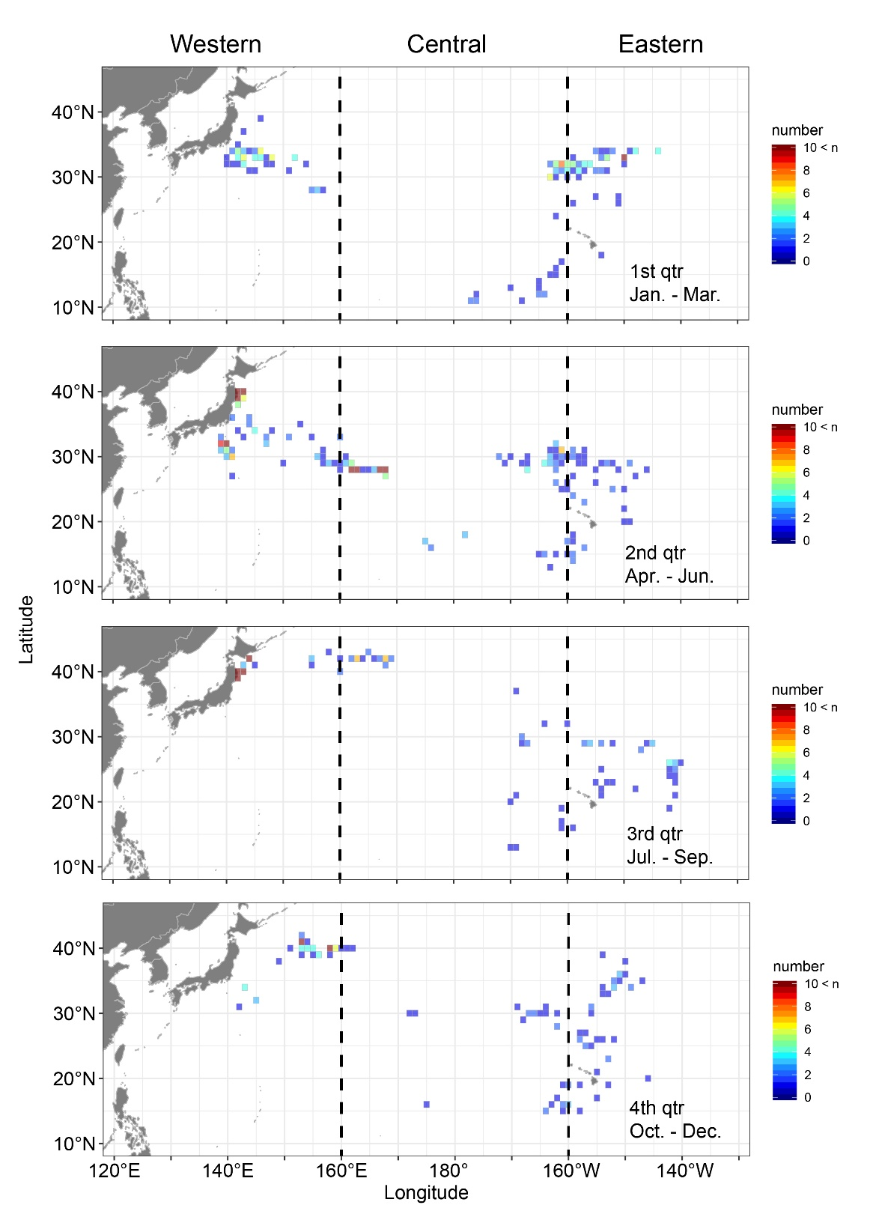
Fig. 1 Spatial and quarterly distributions of swordfish gonad samples in the North Pacific for histological observation. Ovarian samples used for histological observation (i.e., ovaries fixed in raw conditions with 10% formalin or ALTFix) were aggregated into 1° x 1° grid cells.
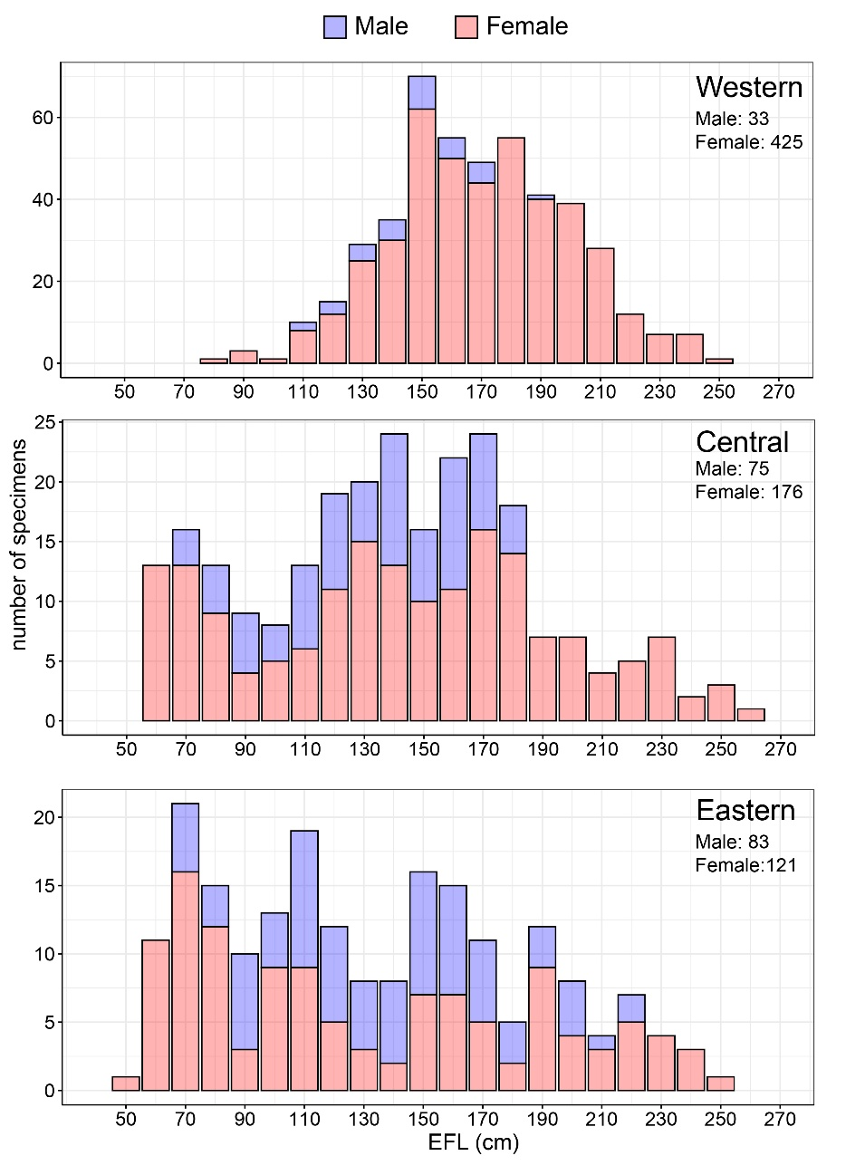
Fig. 2 Size frequency distribution of sampled swordfish by sex and sampling area in the North Pacific. Blue and red bars represent males and females, respectively. EFL: Eye–Fork-Length

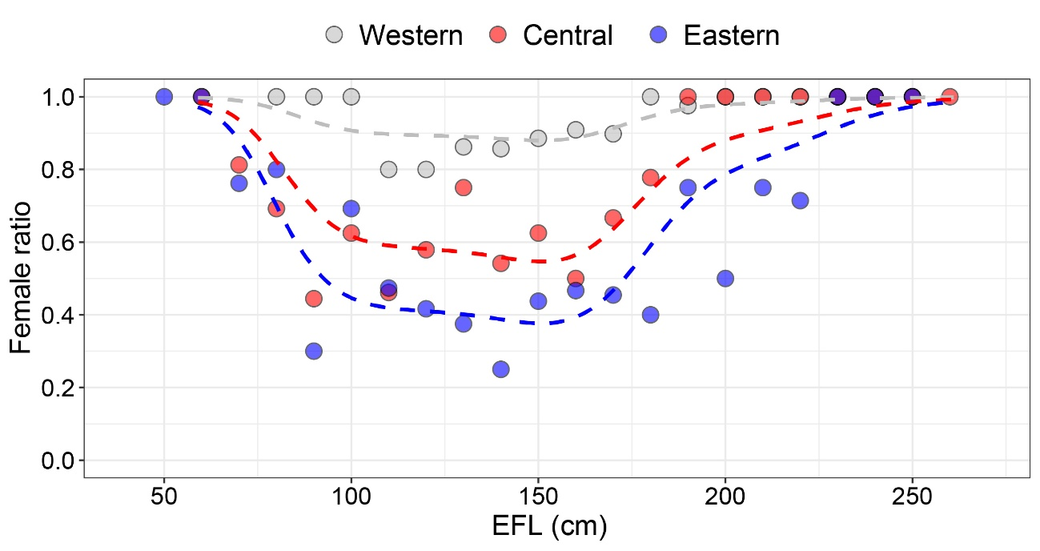
Fig. 3 Sex ratio of swordfish catch in the North Pacific by eye–fork length class (10cm intervals)
Gray, red, and blue filled circles represent female ratios estimated for the western, central, and eastern areas, respectively. The dashed line indicates predicted values from the GAM analysis.
EFL: eye-fork length

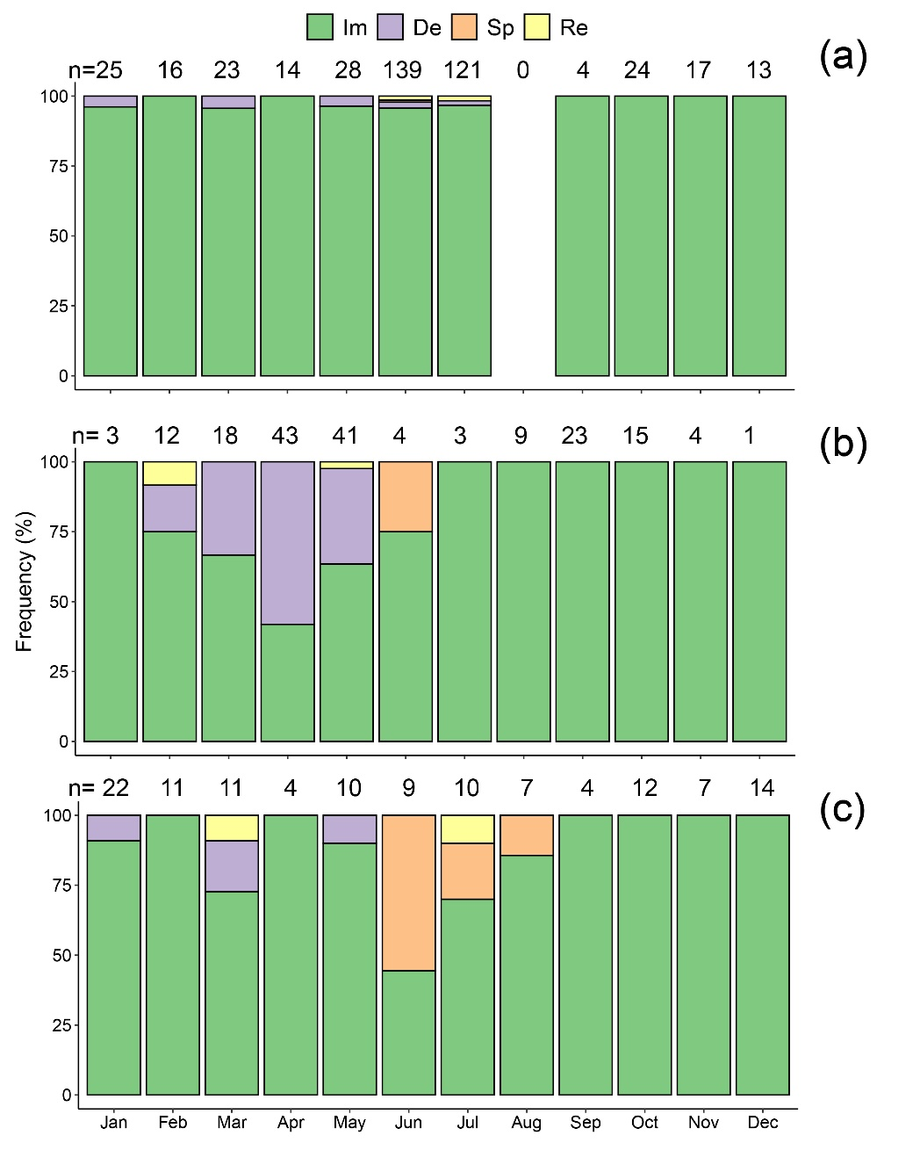
Fig. 4 Monthly trends in ovarian maturity phases of swordfish in each sampling area of the North Pacific: (a) Western, (b) Central, and (c) Eastern areas. De: Developing phase; Im: Immature-regenerating phase; n: number of specimens; Re: Regressing phase; Sp: Spawning capable phase.

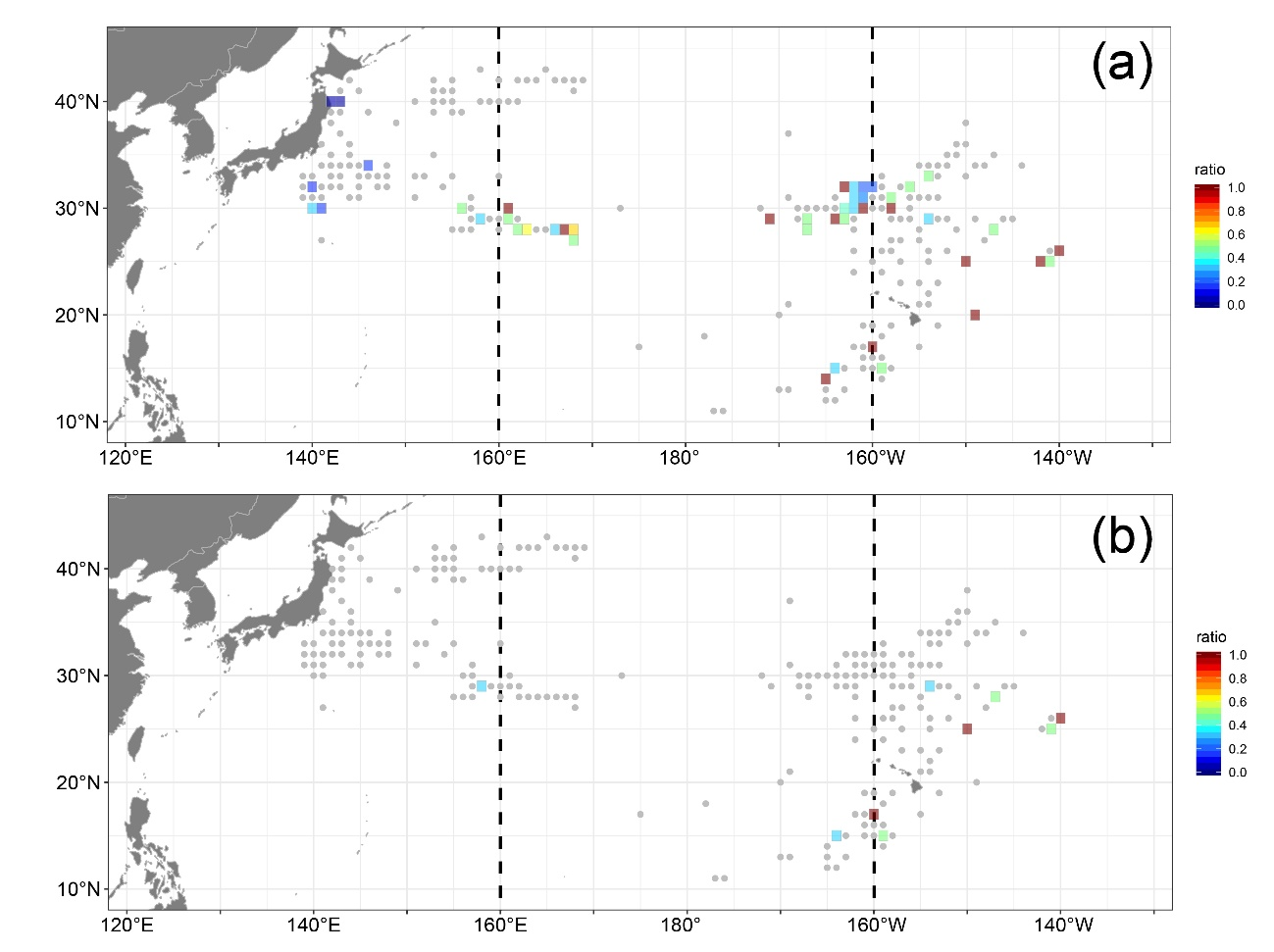
Fig. 5 Spatial distributions (aggregated into 1° x 1° grid cells) of the relative frequency of mature female swordfish (i.e., Developing, Regressing, and Spawning capable) (a) and spawning-capable female swordfish (b) sampled in the North Pacific Ocean. Gray dots indicate zero frequency.

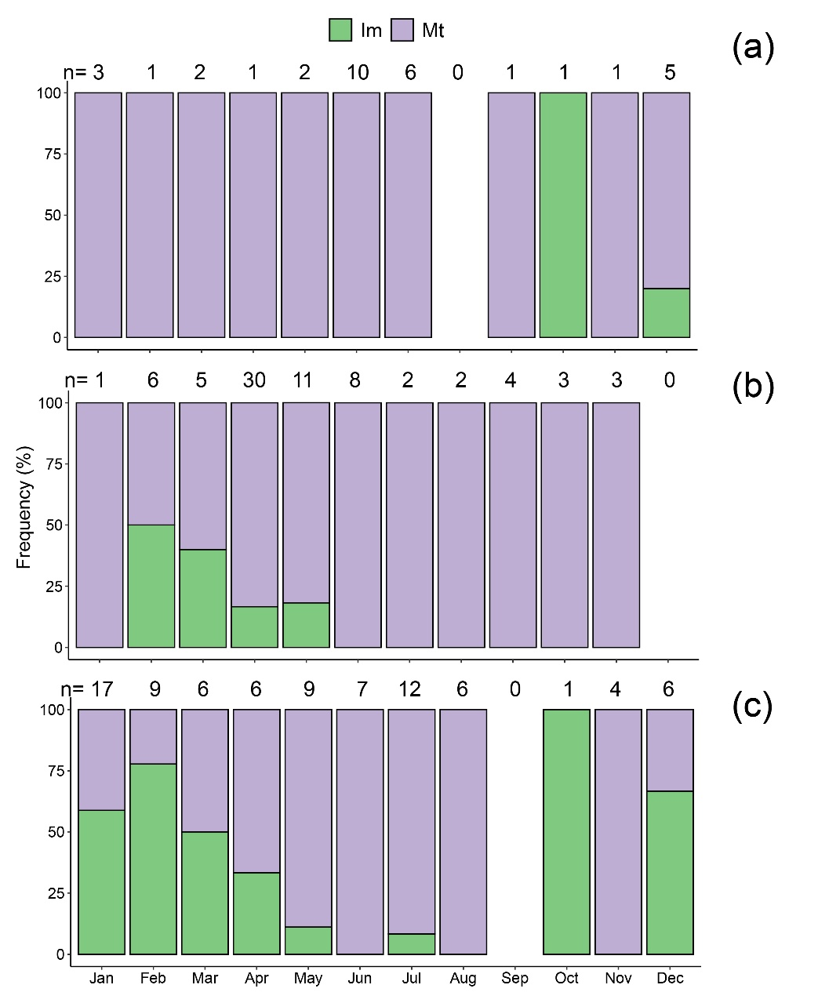
Fig. 6 Monthly trends in testis maturity phases of swordfish in each sampling area of the North Pacific: (a)Western, (b) Central, and (c) Eastern areas. Im: Immature fish; Mt: Mature fish; n: number of specimens.

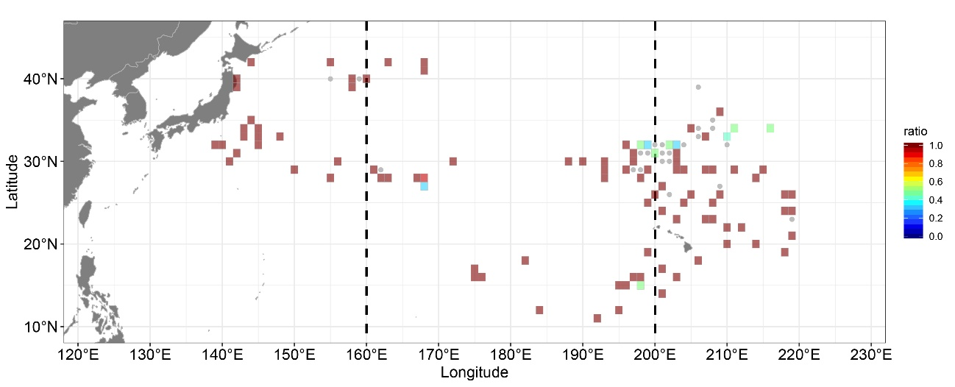
Fig. 7 Spatial distributions (aggregated into 1° x 1° grid cells) of the frequency of mature male swordfish sampled in the North Pacific Ocean. Gray dots indicate zero frequency.

Appendix figures
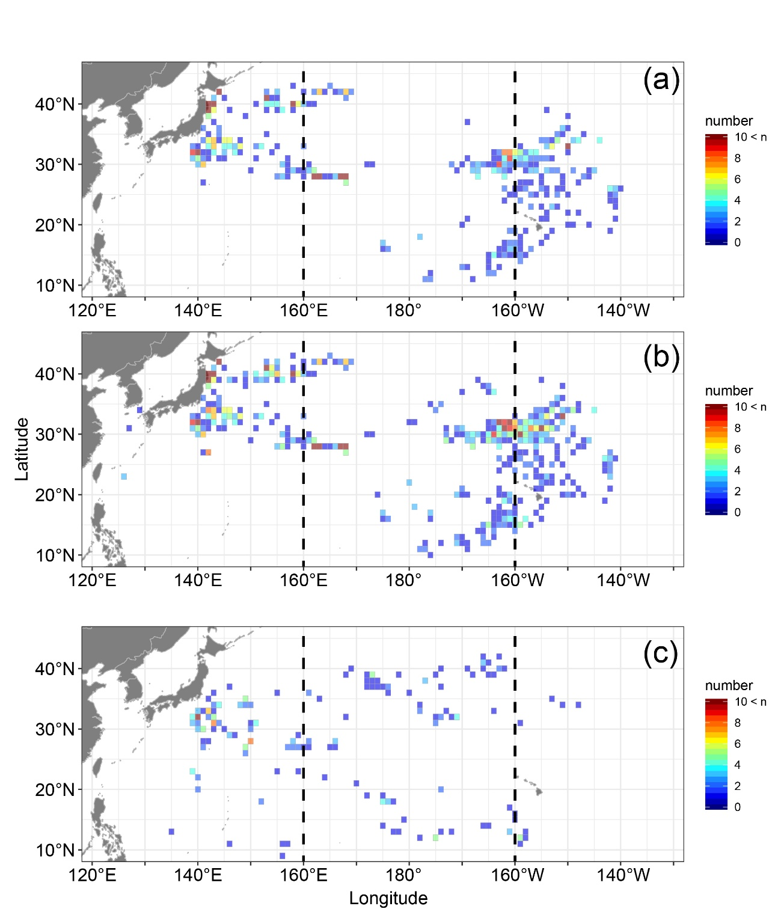
Fig.S1 Comparison of spatial distributions of swordfish gonad samples in the North Pacific between this study and the IBBS program database (accessed on 2025/11/26): (a) Gonad samples used for histological maturity analysis in this study, (b) Raw gonads recorded in the IBBS program database, and (c) Frozen gonads recorded in the IBBS program database

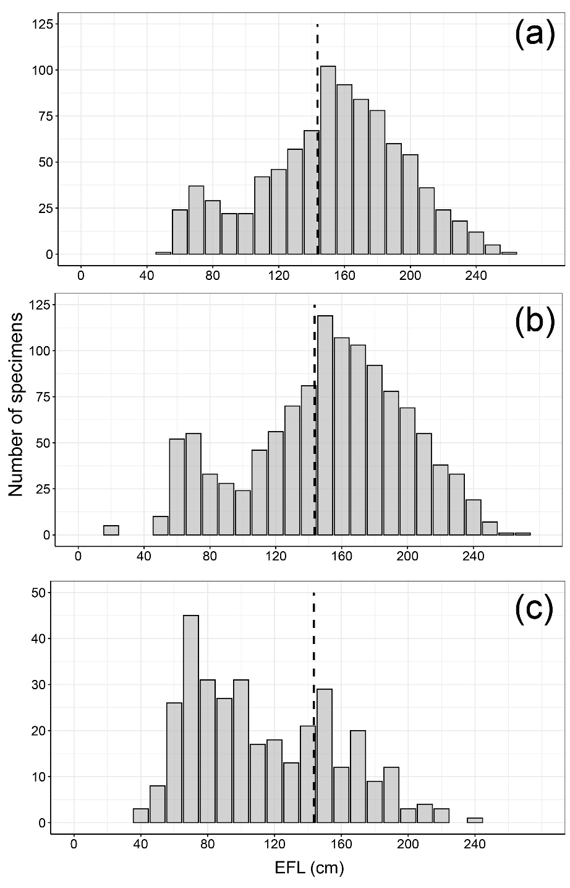
Fig. S2 Comparison of size frequency distributions of swordfish gonad samples in the North Pacific between this study and the IBBS program database (accessed on 2025/11/26): (a) Gonad samples used for histological maturity analysis in this study, (b) Raw gonads recorded in the IBBS program database, and (c) Frozen gonads recorded in the IBBS program database. The vertical line indicates the 50% size at maturity used in the last stock assessment. EFL: eye-fork length

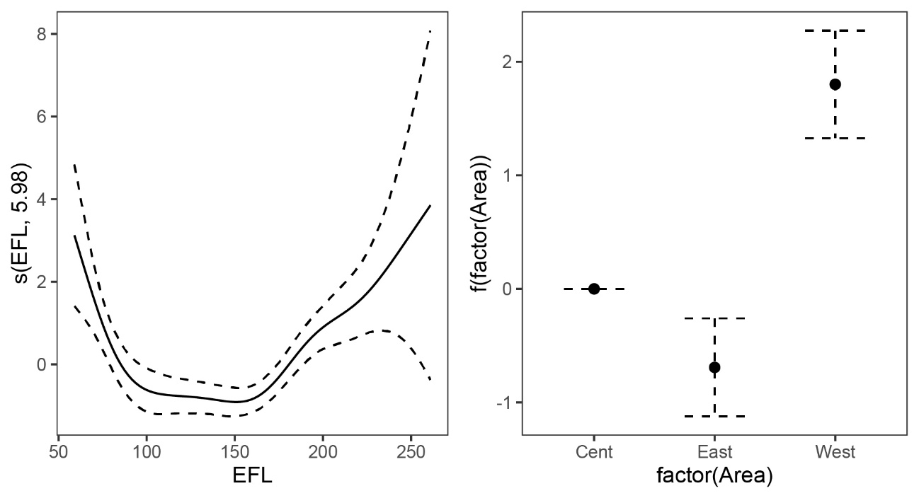
Fig. S3 Partial effects of eye-fork-length (left panel) and area (right panel) on the probability of female occurrence (sex ratio) among swordfish in the North Pacific. EFL: eye-fork length.

